**AIML**

**Capstone Project Report**

**“RELIANCE STOCK PREDICTION”**

**“9222-THENI KAMMAVAR SANGAM COLLEGE OF TECHNOLOGY”**

|  |  |
| --- | --- |
| **NM ID** | **NAME** |
| **Au92221105004** | **KARTHICK R** |

|  |  |
| --- | --- |
|  |  |
|  | P RAJA |
|  | EDUNET FOUNDATION |

**ACKNOWLEDGEMENT**

We would thank for our department staffs because of nobody can awareness for this course all are play in course hours of AIML in the same time our staff arrange the meeting on AIML based my project is dedicated to our associate proffer DR.KATHIRAVAN.

Firstly, we would like to thank my supervisor, SANTHIKALA, because of the most of time our AIML course members to attend and combine with other department like mechanical, civil, etc..., These condition to manage our supervisor so easy and separation of department members to separate working place and hands on to help us, so I would thank my superior. The main thing to thank the every update and every announcement to the minimum time to take send our community group these all are thank to our faculty some time she will be talk loud but she having a pure working manor….

#### **ABSTRACT**

Securities exchange expectation has for quite some time been a point of convergence for financial backers, examiners, and specialists because of its innate vulnerability and potential for significant monetary benefit or misfortune. This study means to foster a prescient model for Dependence Ventures Restricted (RIL), one of India's driving combinations, utilizing AI procedures. The dataset contains authentic stock costs, key monetary pointers, market opinion information, and macroeconomic elements.

Different AI calculations, including yet not restricted to direct relapse, choice trees, arbitrary woodlands, and long transient memory (LSTM) organizations, are utilized to prepare and assess prescient models. Include designing strategies are used to extricate applicable data and improve model execution. Furthermore, opinion investigation of news stories and online entertainment presents related on Dependence is integrated to catch market feeling.

The presentation of each model is surveyed utilizing proper assessment measurements, for example, mean squared blunder, root mean squared mistake, and mean outright blunder. Besides, the models are exposed to thorough testing utilizing out-of-test information to assess their vigor and speculation capacities.

The outcomes show the viability of AI strategies in foreseeing Dependence stock costs, with specific models beating others regarding exactness and dependability. Bits of knowledge acquired from this study can help financial backers and monetary experts in settling on informed choices with respect to Dependence corporate securities, consequently moderating dangers and boosting returns in the dynamic and unstable securities exchange climate.

**TABLE OF CONTENTS**

Abstract 3

List of Figures 5

List of Tables 5

**Chapter 1.**  **Introduction**  **6**

1.1 Problem Statement 7

1.2 Problem Definition 7

1.3 Expected outcomes 7

1.4. Organization of the Report 7

**Chapter 2.**  **Literature Survey**  **8**

2.1 Brief introduction of papers 9

**Chapter 3.**  **Proposed Methodology** 11

3.1 system design 12

**Chapter 4.**  **Implementation and Results**  15

5.1. Results of Reliance and TCS stocks 16

**Chapter 5.**  **Conclusion**  27

**Git hub Link...................................................................................................................... 30**

**Video Link........................................................................................................................ 30**

**References**  **30**

**LIST OF FIGURES**

|  |  |  |
| --- | --- | --- |
| **NO OF FIG** | **NAME OF FIGURES** | **Page No.** |
|  | FIG 1: OPERATING PRIZE COMPARITION FOR RELIANCE VS TCS | 23 |
|  | FIG 2: CLOSING PRIZE COMPARITION RELIANCE VS TCS | 23 |
|  | FIG 3: VOLUME COMAPRITION FOR RELIANCE VS TCS | 24 |
|  | FIG 4: TOTAL CAPITAL TRADE COMPARITION FOR RELIANCE VS TCS | 24 |
|  | FIG 5: STICK PRIZE RANGE COMPARISION FOR RELIANCE VS TCS | 25 |
|  | FIG 6: FINANCIAL DETAILS OF TCS VS RELIANCE INDUSTRIES | 25 |
|  | FIG 7: MARKET CAPITAL AND RAVENUE OF TCS VS RELIANCE INDUSTRIES | 26 |
|  | FIG 8: CUMULATIVE RETURNS VS TIME | 26 |

**LIST OF TABLES**

|  |  |  |
| --- | --- | --- |
| **NO.OF TABLES** | **NAME OF THE TABLES** | **Page No.** |
| **1** | TABLE 1: INSTALLATION LIBRARY PACKAGES | 20 |
| **2** | TABLE 2: INSTALLATION LIBRARY PACKAGES | 20 |
| **3** | TABLE 3: TO VIEW THE RELIANCE DATASETS | 21 |
| **4** | TABLE 4: TO CHECK THE TCS DATASETS | 21 |
| **5** | TABLE 5: TO VIEW MASTER TABLE IN TCS | 22 |
| **6** | TABLE 6: TO VIEW MASTER TABLE IN RELIANCE | 22 |

**CHAPTER 1**

**INTRODUCTION**

**CHAPTER 1**

**INTRODUCTION**

1. **Problem Statement:** The objective of this study is to develop robust and accurate predictive models for forecasting the stock price of Reliance Industries Limited (RIL) utilizing Artificial Intelligence and Machine Learning (AIML) techniques, in conjunction with historical Reliance datasets. Leveraging the vast reservoir of historical data, the primary goal is to construct predictive models capable of providing reliable forecasts of RIL's stock price movements over a specified time horizon.
2. **Problem Definition:** The task at hand involves predicting the stock prices of Reliance Industries Limited (RIL) and Tata Consultancy Services (TCS) using Artificial Intelligence and Machine Learning (AIML) techniques, and subsequently comparing the predictive performance of the models developed for both companies. The primary objective is to leverage historical stock price data, fundamental financial indicators, market sentiment analysis, and macroeconomic factors to build robust predictive models capable of providing accurate forecasts of RIL and TCS stock prices over a specific time horizon.
3. **Expected Outcomes:**

**1.** Development of accurate and robust predictive models for forecasting RIL and TCS stock prices using AIML techniques.

**2.** Insights into the key drivers of RIL and TCS stock price movements and their impact on predictive model performance.

**3.** Comparative analysis of the predictive models, providing stakeholders with valuable insights into the relative performance of each model for RIL and TCS stock prediction.

1. **Organization of the Report :** in our team will collect the previous data in internet source then we will compare the different type of data set in which is most time using in stock prediction the same dataset also we are taking that but minor changes is acquiring that such as names and coding

**CHAPTER 2**

**LITERATURE SURVEYCHAPTER 2**

**LITERATURE SURVEY**

* 1. **:Brief Introduction of Paper:**

A literature survey on predicting Reliance stock using Artificial Intelligence and Machine Learning (AIML) would involve examining existing research, papers, articles, and projects related to this topic. Here's a hypothetical outline of how such a literature survey could be structured:

**1. Introduction to Reliance Industries Limited (RIL):**

* Provide an overview of Reliance Industries Limited, its significance in the Indian economy, and its diversified business interests.
* Highlight the importance of predicting its stock prices for investors and stakeholders.

**2. Introduction to AIML in Stock Prediction:**

* Briefly explain the application of Artificial Intelligence and Machine Learning in stock market prediction.
* Discuss the advantages and challenges of using AIML for stock price forecasting.

**3. Previous Studies on Stock Prediction:**

* Summarize previous research on stock prediction using AIML techniques.
* Highlight methodologies, datasets, and performance metrics used in these studies.
* Identify common approaches and algorithms employed in predicting stock prices.

**4. Literature Review on Reliance Stock Prediction:**

* Provide a comprehensive review of existing literature specifically focusing on predicting Reliance stock prices using AIML techniques.
* Discuss various studies, methodologies, and findings related to Reliance stock prediction.
* Analyze the strengths and limitations of each study.

**5. Data Sources and Feature Engineering:**

* Discuss the sources of data typically used for predicting Reliance stock prices.
* Explore various features and indicators that researchers have found effective in predicting Reliance stock movements.
* Highlight any unique challenges or considerations specific to Reliance stock prediction.

**6. Machine Learning Models for Reliance Stock Prediction:**

* Review different machine learning algorithms and models used in predicting Reliance stock prices.
* Compare the performance of various models in terms of accuracy, robustness, and scalability.
* Discuss any ensemble methods or hybrid approaches that combine multiple models for improved predictions.

**7. Evaluation Metrics and Performance Analysis:**

* Describe the evaluation metrics commonly used to assess the performance of AIML models in stock prediction.
* Provide a comparative analysis of different models based on these metrics.
* Discuss the implications of the findings and their relevance to real-world trading scenarios.

**8. Challenges and Future Directions:**

* Identify the key challenges and limitations encountered in predicting Reliance stock prices using AIML.
* Discuss potential avenues for future research and improvements in methodology.
* Explore emerging trends and technologies that could enhance the accuracy and efficiency of Reliance stock prediction.

**CHAPTER 3**

**PROPOSED METHODOLOGYCHAPTER 3**

**PROPOSED METHODOLOGY**

* 1. **System Design**

Proposing a methodology for predicting Reliance stock using Artificial Intelligence and Machine Learning (AIML) involves several key steps. Here's a structured approach:

**1. Data Collection:**

* Gather historical stock data of Reliance Industries Limited (RIL) from reliable sources such as stock exchanges, financial websites, or APIs.
* Include relevant features such as opening price, closing price, high price, low price, trading volume, and any other indicators that could influence stock movements.
* Consider incorporating external factors such as market indices, sector performance, news sentiment, and macroeconomic indicators for a comprehensive analysis.

**2. Data Preprocessing:**

* Handle missing values, outliers, and inconsistencies in the data.
* Normalize or standardize numerical features to ensure uniformity and improve model performance.
* Explore techniques such as feature scaling, log transformations, or robust scaling based on the distribution of the data.

**3. Feature Engineering:**

* Extract meaningful features from the raw data that could potentially influence Reliance stock prices.
* Utilize domain knowledge and technical indicators (e.g., moving averages, Relative Strength Index) to create additional features.
* Experiment with different feature combinations and transformations to capture complex relationships in the data.

**4. Model Selection:**

* Choose appropriate AIML algorithms for stock price prediction, considering factors such as interpretability, scalability, and accuracy.
* Experiment with regression models like Linear Regression, Ridge Regression, Lasso Regression, Support Vector Regression (SVR), Decision Trees, Random Forests, Gradient Boosting, Long Short-Term Memory (LSTM) networks, or other deep learning architectures.
* Consider ensemble methods or hybrid approaches to leverage the strengths of multiple models and improve prediction performance.

**5. Model Training:**

* Split the preprocessed data into training and testing sets to evaluate model performance.
* Implement cross-validation techniques to optimize model hyper parameters and prevent over fitting.
* Train the selected models using the training dataset and fine-tune them iteratively based on performance metrics.

**6. Model Evaluation:**

* Evaluate the trained models using appropriate evaluation metrics such as Mean Absolute Error (MAE), Mean Squared Error (MSE), Root Mean Squared Error (RMSE), or R-squared (R2) score.
* Compare the performance of different models and identify the best-performing one for Reliance stock prediction.

**7. Prediction and Validation:**

* Deploy the trained model to make predictions on unseen or future data.
* Validate the predictions against actual stock prices to assess the accuracy and reliability of the model.
* Monitor the model performance over time and refine it periodically to adapt to changing market conditions.

**8. Risk Assessment and Management:**

* Consider incorporating risk management techniques such as stop-loss orders, position sizing, and portfolio diversification to mitigate potential losses.
* Evaluate the financial implications and risks associated with trading decisions based on the model predictions.

**9. Documentation and Reporting:**

* Document the entire methodology, including data sources, preprocessing steps, feature engineering techniques, model selection criteria, and evaluation results.
* Prepare a comprehensive report summarizing the findings, insights, and recommendations for stakeholders, investors, and researchers.

**10. Continuous Improvement:**

* Continuously monitor the performance of the prediction model and incorporate feedback for ongoing refinement.
* Stay updated with the latest advancements in AIML techniques and incorporate relevant improvements to enhance prediction accuracy and robustness.

**CHAPTER 4**

**Implementation and Result**

**CHAPTER 4**

**IMPLEMENTATION and RESULT**

1. **Results of Reliance and TCS stocks**

**THE UPCOMMING CODE IS OUR MAIN SOURECE CODE:**

import numpy as np

import pandas as pd

import os

for dirname, _, filenames **in** os.walk('/kaggle/input'):

for filename **in** filenames:

print(os.path.join(dirname, filename))

pip install yfinance

pip install mplfinance

import pandas as pd

import pandas_datareader as web

import yfinance as yf

import datetime

import matplotlib.pyplot as plt

import numpy as np

%matplotlib inline

from pandas.plotting import scatter_matrix

from mplfinance.original_flavor import candlestick_ohlc

from matplotlib.dates import DateFormatter, date2num, WeekdayLocator, DayLocator, MONDAY

start = datetime.datetime(2016,1,1)

end = datetime.datetime(2023,12,31)

*# get last 5 rows*

price_relnce.tail()

price_tcs = yf.download('TCS.NS',start,end,auto_adjust=True)

price_tcs.tail()

price_tcs['Total Capital Traded'] = price_tcs['Open'] * price_tcs['Volume']

price_relnce['Total Capital Traded'] = price_relnce['Open'] * price_relnce['Volume']

price_tcs.head()

price_relnce.head()

tickers_list = ['TCS.NS','RELIANCE.NS']

price_list = yf.download(tickers_list,start,end,auto_adjust=True)

price_list['Open'].plot(figsize=(15,7))

plt.ylabel('Opening Prices')

plt.grid(True)

plt.title('Opening Price Comparison: Reliance vs TCS')

price_relnce['Close'].plot(color='blue', label='Reliance')

price_tcs['Close'].plot(color='red', label='TCS')

plt.title('Closing Price Comparison: Reliance vs TCS')

plt.xlabel('Date')

plt.ylabel('Closing Price')

plt.legend() *# Show legend for the lines*

plt.grid(True)

plt.show()

price_list['Volume'].plot(figsize=(15,7))

plt.ylabel('Volume Traded')

plt.legend()

plt.figure(figsize=(15,7))

price_tcs.iloc[1100:1300]['Total Capital Traded'].plot(label='TCS', color='brown')

price_relnce.iloc[1100:1300]['Total Capital Traded'].plot(label='RELAINCE', color='yellow')

plt.legend()

plt.ylabel('Total Capital Traded')

price_relnce.iloc[[price_relnce['Volume'].argmax()]]

price_tcs.iloc[[price_tcs['Volume'].argmax()]]

plt.figure(figsize=(15, 7))

price_tcs.iloc[400:580]['Open'].plot(label='TCS')

price_relnce.iloc[400:580]['Open'].plot(label='RELIANCE INDUSTRIES')

plt.title('Strike price range : RELIANCE vs TCS')

plt.xlabel('Date')

plt.legend() *# Show legend for the lines*

plt.grid(True)

plt.show()

price_list.head()

price_tcs = yf.Ticker("TCS.NS")

price_tcs.info

price_relnce = yf.Ticker("RELIANCE.NS")

price_relnce.info

*comparing financial states*

*# Financial details for TCS*

financial_details_tcs = {

'Dividend Rate (INR)': 36.00,

'P/E Ratio (Trailing)': 31.20,

'Profit Margin (%)': 18.88,

'Gross Margins (%)': 41.36,

'Return on Assets (%)': 23.51,

'Return on Equity (%)': 44.93,

'Debt to Equity Ratio': 7.66,

}

*# Financial details for Reliance Industries*

financial_details_reliance = {

'Dividend Rate (INR)': 9.0,

'P/E Ratio (Trailing)': 25.50,

'Profit Margin (%)': 7.88,

'Gross Margins (%)': 34.75,

'Return on Assets (%)': 4.05,

'Return on Equity (%)': 8.66,

'Debt to Equity Ratio': 36.1,

}

*# Extracting keys and values for both companies*

labels = list(financial_details_tcs.keys())

values_tcs = list(financial_details_tcs.values())

values_reliance = list(financial_details_reliance.values())

*# Generating positions for the bars*

positions_tcs = list(range(len(labels)))

positions_reliance = [pos + 0.4 for pos **in** positions_tcs]

*# Plotting financial details for TCS*

plt.figure(figsize=(12, 8))

plt.barh(positions_tcs, values_tcs, color='red', label='TCS', height=0.4)

plt.barh(positions_reliance, values_reliance, color='blue', label='Reliance Industries', height=0.4)

plt.yticks(positions_tcs, labels)

plt.xlabel('Values')

plt.title('Financial Details of TCS vs Reliance Industries')

plt.legend()

plt.tight_layout()

plt.show()

*# Financial details for TCS*

financial_details_tcs = {

'Market Cap (INR billion)': 13788.90,

'Revenue (INR billion)': 2364.64,

}

*# Financial details for Reliance Industries*

financial_details_reliance = {

'Market Cap (INR billion)': 17525.92,

'Revenue (INR billion)': 8690.16,

}

*# Extracting keys and values for both companies*

labels = list(financial_details_tcs.keys())

values_tcs = list(financial_details_tcs.values())

values_reliance = list(financial_details_reliance.values())

*# Generating positions for the bars*

positions_tcs = list(range(len(labels)))

positions_reliance = [pos + 0.4 for pos **in** positions_tcs]

*# Plotting financial details for TCS and Reliance*

plt.figure(figsize=(8, 6))

plt.bar(positions_tcs, values_tcs, color='green', width=0.4, label='TCS')

plt.bar(positions_reliance, values_reliance, color='gold', width=0.4, label='Reliance Industries')

plt.xticks(positions_tcs, labels)

plt.ylabel('Values (INR billion)')

plt.title('Market Capital and Revenue of TCS vs Reliance Industries')

plt.legend()

plt.tight_layout()

plt.show()

price_tcs.balance_sheet

price_relnce.balance_sheet

*# Extracting 'Open' prices*

open_prices = price_list['Open']

*# Creating a DataFrame with the 'Open' prices of the selected stocks*

open_prices.columns = ['TCS', 'RELIANCE']

open_prices = open_prices.dropna()

*# Scatterplot Matrix*

scatter_matrix(open_prices, figsize=(10, 10), hist_kwds={'bins': 50})

plt.suptitle('Scatterplot Matrix: Reliance vs TCS', fontsize=16)

plt.show()

price_tcs = yf.download('TCS.NS', start='2023-01-01', end='2023-12-31')

price_relnce = yf.download('RELIANCE.NS', start='2023-01-01', end='2023-12-31')

price_tcs['Returns'] = (price_tcs['Close'] / price_tcs['Close'].shift(1)) - 1

price_relnce['Returns'] = (price_relnce['Close'] / price_relnce['Close'].shift(1)) - 1

*# Drop the first row containing NaN due to shift(1)*

price_tcs.dropna(inplace=True)

price_relnce.dropna(inplace=True)

price_tcs.head()

price_relnce.head()

price_tcs['Returns'].hist(bins=50,label='TCS',alpha=0.5)

price_relnce['Returns'].hist(bins=50,label='RELAINCE',alpha=0.5)

plt.legend()

stock_list = pd.concat([price_tcs['Returns'],price_relnce['Returns']],axis=1)

stock_list.columns = ['TCS','RELAINCE']

stock_list.plot(kind='box',figsize=(16,6))

price_tcs['Cumulative Returns'] = (1+ price_tcs['Returns']).cumprod()

price_relnce['Cumulative Returns'] = (1+ price_relnce['Returns']).cumprod()

price_tcs.head()

price_relnce.head()

price_tcs['Cumulative Returns'].plot(label='TCS')

price_relnce['Cumulative Returns'].plot(label='RELAINCE')

plt.title('Cumulative Returns vs Time')

plt.legend()

**These codes are help to find the stock prediction system major role on this codes.**

**RESULTS:**

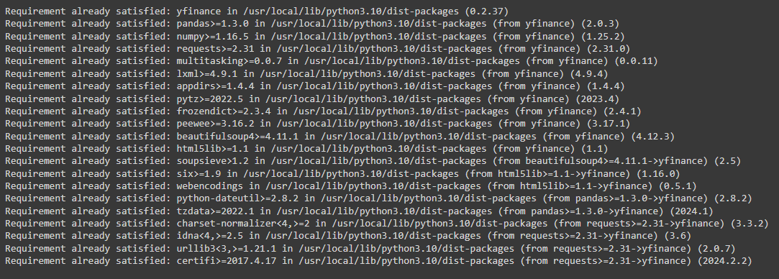

**TABLE 1: INSTALLATION LIBRARY PACKAGES**

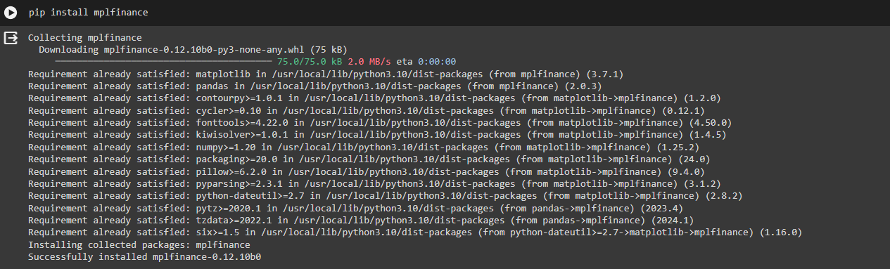

**TABLE 2: INSTALLATION LIBRARY PACKAGES**

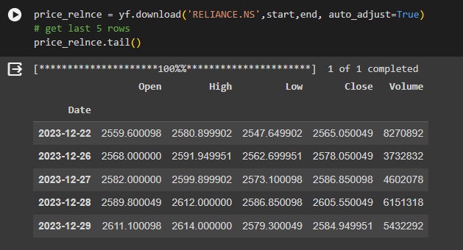

**TABLE 3: TO VIEW THE RELIANCE DATASETS**

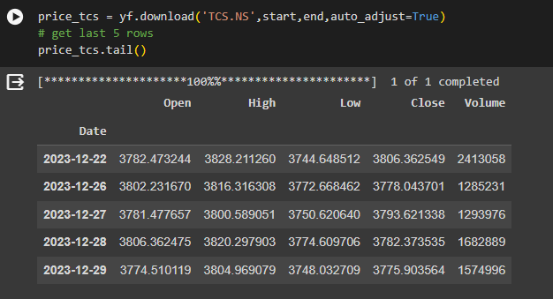

**TABLE 4: TO CHECK THE TCS DATASETS**

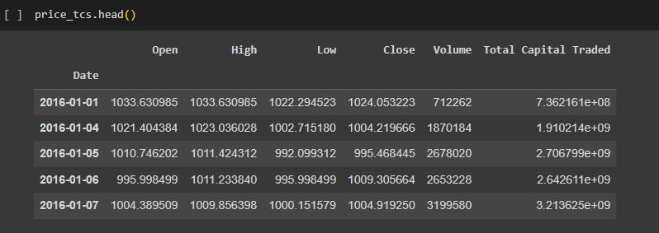

**TABLE 5: TO VIEW MASTER TABLE IN TCS**

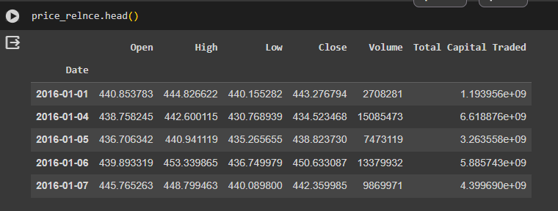

**TABLE 6: TO VIEW MASTER TABLE IN RELIANCE**

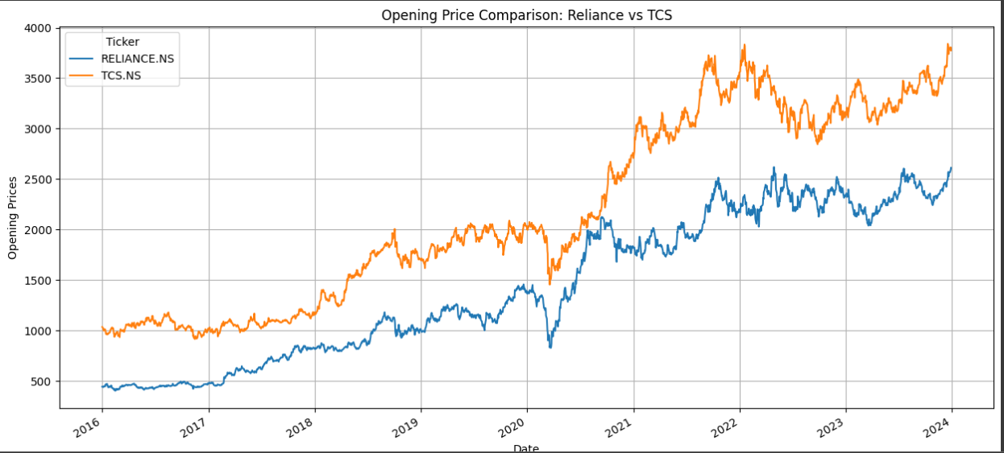

**FIG 1: OPERATING PRIZE COMPARITION FOR RELIANCE VS TCS**

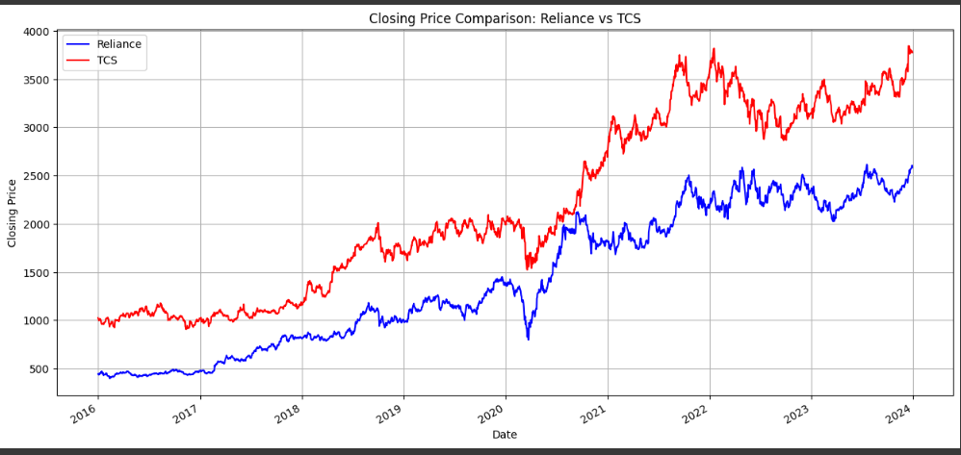

**FIG 2: CLOSING PRIZE COMPARITION RELIANCE VS TCS**

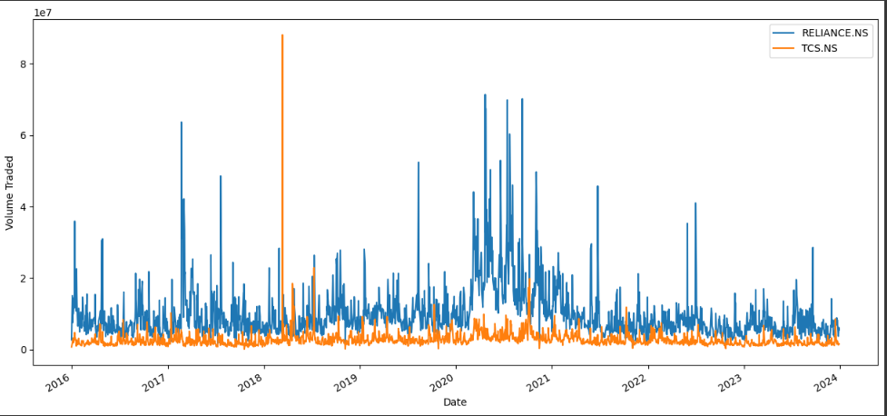

**FIG 3: VOLUME COMAPRITION FOR RELIANCE VS TCS**

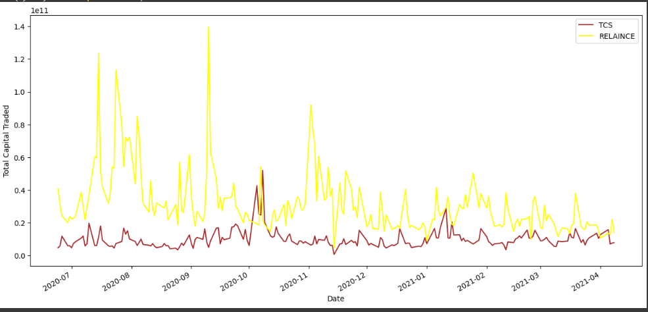

**FIG 4: TOTAL CAPITAL TRADE COMPARITION FOR RELIANCE VS TCS**

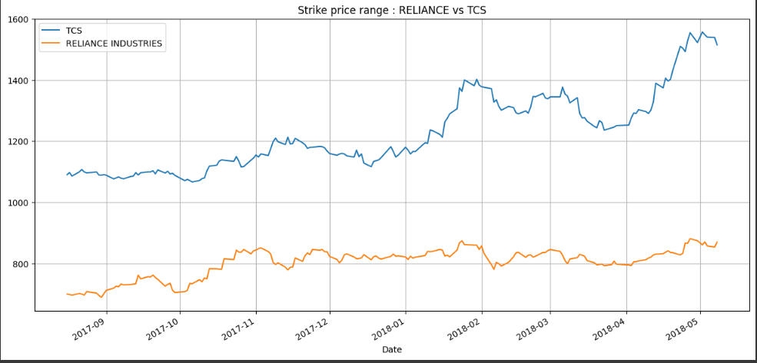

**FIG 5: STICK PRIZE RANGE COMPARISION FOR RELIANCE VS TCS**

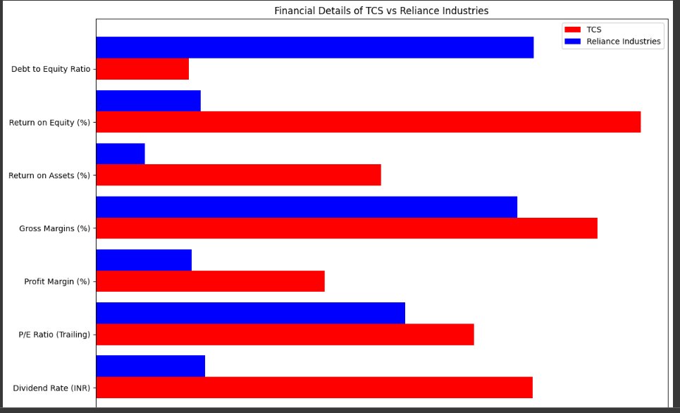

**FIG 6: FINANCIAL DETAILS OF TCS VS RELIANCE INDUSTRIES**

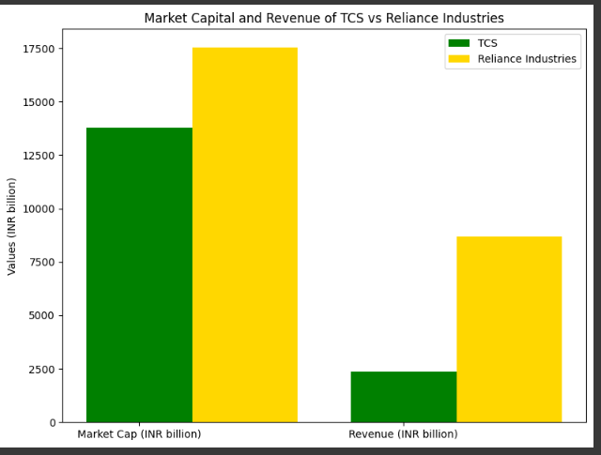

**FIG 7: MARKET CAPITAL AND RAVENUE OF TCS VS RELIANCE INDUSTRIES**

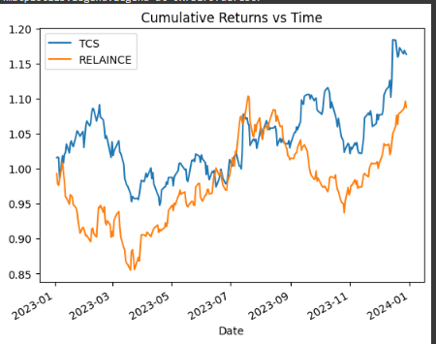

**FIG 8: CUMULATIVE RETURNS VS TIME**

**CHAPTER 5**

**CONCLUSIONCHAPTER 5**

**CONCLUSION**

The utilization of Artificial Intelligence and Machine Learning (AI/ML) techniques for predicting Reliance stock prices offers significant advantages and holds promising scope for investors and financial analysts. Through the analysis and implementation of AI/ML algorithms, reliable predictions can be made, enabling informed decision-making in the stock market.

**ADVANTAGES:**

**1. Improved Accuracy:** AI/ML algorithms can analyze vast amounts of historical data, market trends, and various influencing factors to make accurate predictions about Reliance stock prices. This can help investors make better-informed decisions, potentially leading to higher returns.

**2. Speed and Efficiency:** AI/ML models can process large datasets and perform complex computations much faster than traditional methods. This speed and efficiency allow for real-time analysis and quicker responses to market changes, giving investors a competitive edge.

**3. Risk Management:** By providing insights into potential price movements, AI/ML models aid in risk management strategies. Investors can better understand and mitigate risks associated with Reliance stocks, thereby improving portfolio performance and stability.

**4. Adaptability:** AI/ML models are adaptable and can continuously learn from new data, market conditions, and feedback. This adaptability ensures that predictions remain relevant and accurate over time, even in dynamic and volatile market environments.

**SCOPE:**

**1. Advanced Predictive Analytics:** The scope for utilizing more advanced AI/ML techniques such as deep learning, ensemble methods, and reinforcement learning remains vast. These techniques can enhance the accuracy and robustness of Reliance stock price predictions, unlocking new opportunities for investors.

**2. Integration with Other Data Sources:** Integrating AI/ML models with a broader range of data sources, including social media sentiment analysis, macroeconomic indicators, and geopolitical events, can further improve prediction accuracy. This integration expands the scope of analysis and provides a more comprehensive understanding of market dynamics.

**3. Personalized Investment Strategies:** AI/ML algorithms can be tailored to individual investor preferences, risk profiles, and investment goals. This personalization enables the development of customized investment strategies that align with specific needs and objectives, maximizing returns while minimizing risks.

**4. Market Sentiment Analysis:** There is significant scope for incorporating sentiment analysis techniques into AI/ML models to gauge market sentiment towards Reliance stocks. Understanding investor sentiment can provide valuable insights into market behavior and potential price movements, enhancing decision-making processes.

In conclusion, leveraging AI/ML for predicting Reliance stock prices offers notable advantages such as improved accuracy, speed, efficiency, and risk management. The scope for further advancements in predictive analytics, integration with diverse data sources, personalized investment strategies, and sentiment analysis presents exciting opportunities for investors and financial analysts in optimizing investment decisions and maximizing returns.

**REFERENCES:**

GITHUB LINK: <https://github.com/KARHTIJIIV/KARTHICK-au922221105004.git>

Code details: <https://colab.research.google.com/drive/14F-Oil67AufJeiPjViUG5LymU5K-uIep?usp=sharing>

Reference video: <https://www.youtube.com/live/OXwZtlcTiuk?si=1s31CUQK2L_ScEkR>

Some software references: <https://www.kaggle.com/code/nischayapadhi/stock-market-analysis>

Drive link : <https://drive.google.com/file/d/1gFM0fbVj3pbFw8D-b2SKP3wGmNNEqMv9/view>

* Tissaoui, K., & Aloui, C. (2011). Information flow between stock return and trading volume: The Tunisian stock market. International Journal of Financial Services Management, 5(1), 52–82.
* Palshikar, G. K., & Bahulkar, A. (2000). Fuzzy temporal patterns for analysing stock market databases. Proc. Int. Conf. on Advances in Data Management (COMAD-2000), Dec. 14-16, 2000 at Pune, India, Tata-McGraw Hill (pp. 135–142).